**UCS802 COMPILER CONSTRUCTION LAB ASSIGNMENT 1**

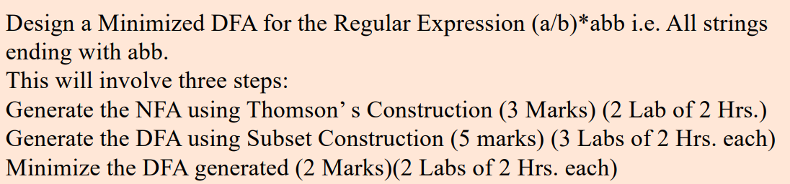

**Step 1: Creating NFA from Regex using Thompson’s Construction**

class NFAState:

    def __init__(self):

      # Dictionary of inputs

        self.transitions = {}

        # list of epsilon transitions

        self.epsilon_transitions = []

    def add_transition(self, input_symbol, state):

        if input_symbol not in self.transitions:

            self.transitions[input_symbol] = set()

        self.transitions[input_symbol].add(state)

    def add_epsilon_transition(self, state):

        self.epsilon_transitions.append(state)

class NFA:

    def __init__(self):

        self.start_state = NFAState()

        self.accept_state = NFAState()

    @staticmethod

    def from_single_symbol(symbol):

        nfa = NFA()

        nfa.start_state.add_transition(symbol, nfa.accept_state)

        print(f"NFA for symbol '{symbol}':")

        print(f"Start state transitions: {nfa.start_state.transitions}\n")

        return nfa

    @staticmethod

    def concatenate(nfa1, nfa2):

        nfa1.accept_state.add_epsilon_transition(nfa2.start_state)

        nfa = NFA()

        nfa.start_state = nfa1.start_state

        nfa.accept_state = nfa2.accept_state

        print(f"NFA after concatenation:")

        print(f"Start state transitions: {nfa.start_state.transitions}\n")

        return nfa

    @staticmethod

    def union(nfa1, nfa2):

        nfa = NFA()

        nfa.start_state.add_epsilon_transition(nfa1.start_state)

        nfa.start_state.add_epsilon_transition(nfa2.start_state)

        nfa1.accept_state.add_epsilon_transition(nfa.accept_state)

        nfa2.accept_state.add_epsilon_transition(nfa.accept_state)

        print(f"NFA after union:")

        print(f"Start state transitions: {nfa.start_state.epsilon_transitions}\n")

        return nfa

    @staticmethod

    def kleene_star(nfa):

        new_nfa = NFA()

        new_nfa.start_state.add_epsilon_transition(nfa.start_state)

        new_nfa.start_state.add_epsilon_transition(new_nfa.accept_state)

        nfa.accept_state.add_epsilon_transition(nfa.start_state)

        nfa.accept_state.add_epsilon_transition(new_nfa.accept_state)

        print(f"NFA after Kleene star:")

        print(f"Start state epsilon transitions: {new_nfa.start_state.epsilon_transitions}\n")

        return new_nfa

# Test building NFA for the regex (a/b)*abb

# We can create another regex expression to compare

def build_nfa_for_expression():

    a_nfa = NFA.from_single_symbol('a')

    b_nfa = NFA.from_single_symbol('b')

    union_nfa = NFA.union(a_nfa, b_nfa)

    kleene_nfa = NFA.kleene_star(union_nfa)

    a_nfa2 = NFA.from_single_symbol('a')

    b_nfa2 = NFA.from_single_symbol('b')

    b_nfa3 = NFA.from_single_symbol('b')

    abb_nfa = NFA.concatenate(a_nfa2, NFA.concatenate(b_nfa2, b_nfa3))

    final_nfa = NFA.concatenate(kleene_nfa, abb_nfa)

    return final_nfa

nfa = build_nfa_for_expression()

**Step 2: Generate DFA using Subset Construction**

class DFAState:

    def __init__(self, nfa_states):

        self.nfa_states = nfa_states

        self.transitions = {}

    def __repr__(self):

        return f"DFAState({[id(state) for state in self.nfa_states]})"

class DFA:

    def __init__(self, nfa):

        self.start_state = None

        self.states = []

        self.final_states = set()

        self.nfa_accept_state = nfa.accept_state

        self.build_from_nfa(nfa)

    def epsilon_closure(self, nfa_states):

        closure = set(nfa_states)

        stack = list(nfa_states)

        while stack:

            state = stack.pop()

            for next_state in state.epsilon_transitions:

                if next_state not in closure:

                    closure.add(next_state)

                    stack.append(next_state)

        return closure

    def move(self, nfa_states, symbol):

        next_states = set()

        for state in nfa_states:

            if symbol in state.transitions:

                next_states.update(state.transitions[symbol])

        return self.epsilon_closure(next_states)

    def build_from_nfa(self, nfa):

        start_closure = self.epsilon_closure([nfa.start_state])

        start_state = DFAState(start_closure)

        self.start_state = start_state

        self.states = [start_state]

        unprocessed_states = [start_state]

        state_mapping = {frozenset(start_closure): start_state}

        print(f"Initial DFA state: {start_state}")

        while unprocessed_states:

            current_dfa_state = unprocessed_states.pop()

            if self.nfa_accept_state in current_dfa_state.nfa_states:

                self.final_states.add(current_dfa_state)

            for symbol in ['a', 'b']:

                next_closure = self.move(current_dfa_state.nfa_states, symbol)

                if frozenset(next_closure) not in state_mapping:

                    new_dfa_state = DFAState(next_closure)

                    self.states.append(new_dfa_state)

                    state_mapping[frozenset(next_closure)] = new_dfa_state

                    unprocessed_states.append(new_dfa_state)

                current_dfa_state.transitions[symbol] = state_mapping[frozenset(next_closure)]

            print(f"Processed DFA state: {current_dfa_state}")

            print(f"Transitions: {current_dfa_state.transitions}\n")

    def is_final(self, state):

        return state in self.final_states

    def simulate(self, input_string):

        """Simulate the DFA with an input string."""

        current_state = self.start_state

        for symbol in input_string:

            if symbol not in current_state.transitions:

                return False  # Invalid transition

            current_state = current_state.transitions[symbol]

        # Check if current state is a final state

        return self.is_final(current_state)

dfa = DFA(nfa)

**Step 3: Minimize DFA**

def minimize_dfa(dfa):

    final_states = [state for state in dfa.states if dfa.is_final(state)]

    non_final_states = [state for state in dfa.states if not dfa.is_final(state)]

    partition = [set(final_states), set(non_final_states)]

    new_partition = []

    print(f"Initial partition: {partition}\n")

    while partition != new_partition:

        if new_partition:

            partition = new_partition

        new_partition = []

        for group in partition:

            subsets = {}

            for state in group:

                transition_signature = tuple(

                    next((i for i, grp in enumerate(partition) if state.transitions.get(symbol) in grp), None)

                    for symbol in ['a', 'b']

                )

                if transition_signature not in subsets:

                    subsets[transition_signature] = set()

                subsets[transition_signature].add(state)

            new_partition.extend(subsets.values())

        print(f"New partition: {new_partition}\n")

    # Build a minimized DFA (actual merging logic omitted for brevity)

# Minimize the DFA and print partitioning

minimize_dfa(dfa)

**Step 4: Using the functions to generate required output**

import re

import itertools

# Function to generate example strings that match the regex

def generate_strings(regex, num_strings=20):

    examples = []

    # Start generating strings with increasing lengths

    for length in range(1, num_strings + 1):

        for combination in itertools.product('ab', repeat=length):

            test_str = ''.join(combination)

            # Check if the generated string matches the regex

            if re.fullmatch(regex, test_str):

                examples.append(test_str)

                if len(examples) >= num_strings:

                    return examples

    return examples

# Ensure all regex characters are lowercase

def convert_regex_to_lowercase(regex):

    return regex.lower()

# Get user input for regular expression

user_regex = input("Enter a regular expression (e.g., (a|b)*abb): ").strip()

user_regex = convert_regex_to_lowercase(user_regex)  # Convert to lowercase

# Generate example strings that match the user-provided regex

test_strings = generate_strings(user_regex)

print(f"Generated strings for '{user_regex}':", test_strings)

# Check if the DFA accepts all example strings

accepted = all(dfa.simulate(test_string) for test_string in test_strings)

# Print result

if accepted:

    print(f"All generated strings matching the regex '{user_regex}' are accepted by the DFA.")

    print("ACCEPT")

else:

    print(f"Not all strings matching the regex '{user_regex}' are accepted by the DFA.")

    print("REJECT")

**Final Output:**

Prompt to enter Regular Expression to compare with (a|b)*abb:



Outputs with different inputs:

* + **(a|b) –** Since all strings generated by this RE will not end with abb the output should be “REJECTED”.

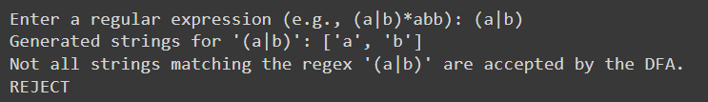

* + **(a|b)* -** Since all strings generated by this RE will not end with abb the output should be “REJECTED”.

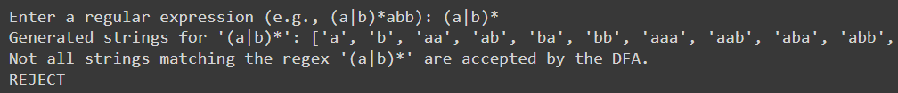

* + **aaa -** Since all strings generated by this RE will not end with abb the output should be “REJECTED”.

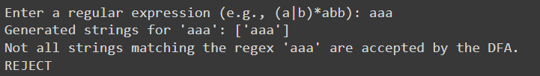

* + **(a|b)*ab -** Since all strings generated by this RE will not end with abb the output should be “REJECTED”.

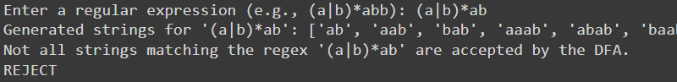

* + **a*abb -** Since all strings generated by this RE will end with abb the output should be “ACCEPTED”.

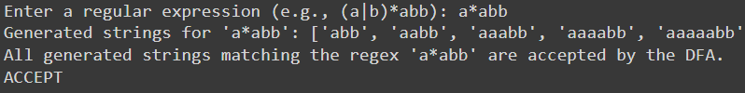

* + **(a|b)*abb -** Since all strings generated by this RE will end with abb the output should be “ACCEPTED”.

